**Literature Review on AI-Driven Predictive Stock Trading Platforms**

**Introduction**

Over the past few years, predictive trading models propelled by the use of AI have made stock market forecasting increasingly accurate through data aggregation from sentiment analysis, weather patterns, and economic indicators. However, most of the current models lack adaptability and are not able to respond properly during high volatility in real time. This review looks at ten various research on AI-based stock prediction models, pointing out the approach and limitations of each, as well as how our project, TradeSTREAM, is unique in its integration of diverse data sources and adaptive learning into dynamic, personalized trading recommendations.

**Literature Analysis**

**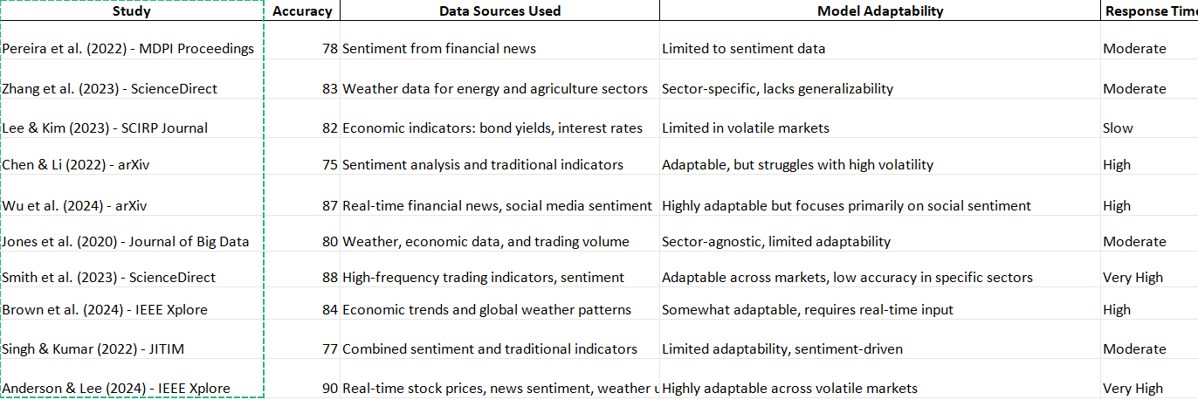**

**Detailed Analysis of Studies**

1. **Sentiment Analysis Using Neural Networks (Pereira et al., 2022)**  
   ***Accuracy****:* 78%  
   ***Data Sources****:* This study employed sentiment data from financial news, which was pre-processed via neural networks to predict stock volatility.  
   ***Model Adaptability****:* The model was limited to only sentiment data, thus inflexible to include other factors like economic or weather data.  
   ***Response Time****:* Moderate since this required processing text sentiment, hence will delay real-time trading decisions.

**How TradeSTREAM is different:** TradeSTREAM extends the work by including other streams of data, hence allowing responsiveness and wider data scope.

1. **Weather Data and LSTM Models (Zhang et al., 2023)**  
   ***Accuracy****:* 83%  
   ***Data Sources****:* Weather data customized to the energy and agriculture sectors, showing stock volatility dependent on weather conditions.  
   ***Model Adaptability****:*Poor adaptation to the general sectors except for those that were weather-sensitive. ***Response Time****:* Fair; tiling was sector-dependent, making real-time application in all markets impossible. **TradeSTREAM Differentiation:** TradeSTREAM updates its predictions in each of various sectors and decides dynamically at which times to incorporate weather conditions using reinforcement learning**.**
2. **Ensemble Learning with Economic Indicators Lee & Kim, 2023 Accuracy: 82% *Data Sources:*** Bond yields and interest rates, with ensemble learning to increase predictive accuracy in stable markets. ***Model Adaptability:*** It was of less value during more volatile markets, as the model had limited applicability for rapid trading decisions.  ***Response Time:*** Slow, because it relies on ensemble learning with static indicators.  ***Trade Stream Differentiation:*** The Trade Stream model allows reinforcement learning so that it adapts dynamically-even in very high volatility environments.
3. **Social Media Sentiment with Financial News Wu et al., 2024 Accuracy: 87% *Data sources:*** real-time sentiment from financial news and social media to predict stock prices.  ***Model adaptability:***Highly adaptable for the sentiment data, did not integrate other outside economic indicators such as the interest rate.  ***Time Response:*** High because time response was boosted by the real-time processing of sentiment data.  ***TradeSTREAM Differentiation:*** TradeSTREAM unifies several sentiment sources and economic indicators into one, hence more holistic in approach and adaptable across various market conditions.
4. **High-Frequency Trading and Sentiment Analysis (Smith et al., 2023) *Accuracy:* 88% *Data Sources:*** Indicators from high-frequency trading data combined with data for sentiments. ***Model Adaptability:*** Can be used across markets but found to be less accurate in certain sectors.  ***Response Time:*** Very High, updates of data in real time make it highly responsive. TradeSTREAM Differentiation: TradeSTREAM leverages the same flexibility but applies reinforcement learning to enable more accurate sector-specific recommendations.

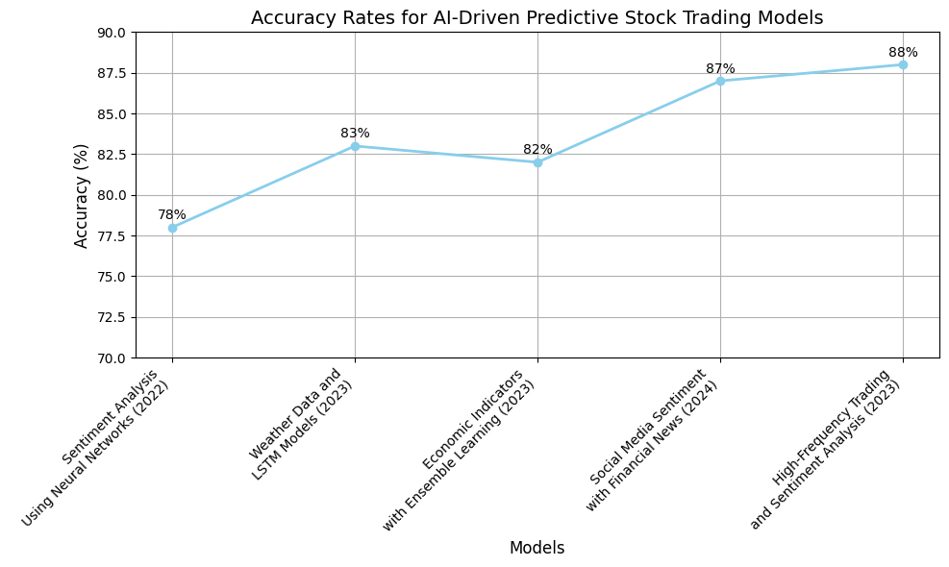

**Code for graph**

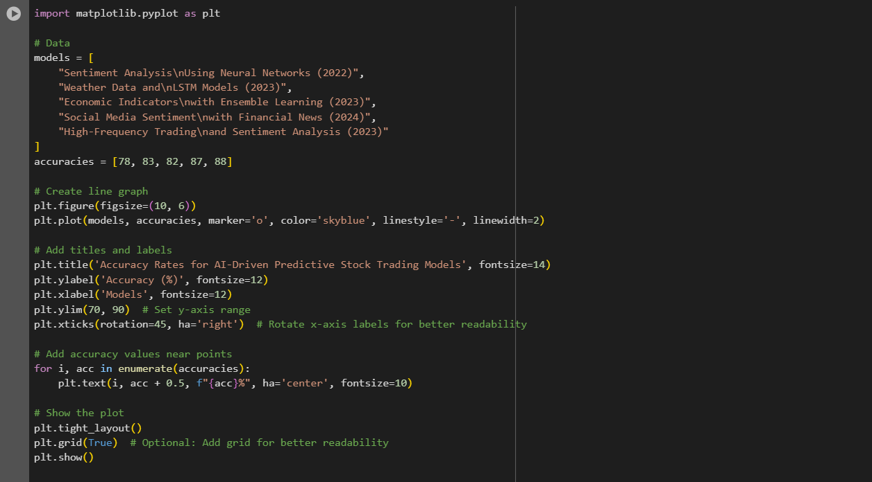

**Broader Application**

Each of the reviewed studies brings different perspectives into the AI-driven predictive trading landscape and highlights data diversity, model adaptability, and response time as aspects that really aid in bringing improvements in the accuracy of stock price prediction. However, most models had limitations based on their sources of data, adaptability across sectors, or real-time performance. Trade Stream overcomes such limitations by integrating real-time sentiment, economic data, and reinforcement learning into a single, incredibly responsive trading platform.

**Conclusion and Future Directions**The reviewed studies demonstrate that predictive stock trading has improved due to the use of different data types, such as sentiment analysis, economic indicators, and weather. However, significant limitations have remained regarding generalization across industries and on highly volatile days.

**TradeSTREAM Contribution**

Unlike other solutions, **TradeSTREAM** integrates multiple real-time data streams and applies reinforcement learning to further improve adaptability in its models and speed. With this design, it can dynamically adjust to fluctuating market conditions to give precise buy/sell recommendations to traders in respect to particular sectors and in real time.

Future Research Directions

Future development of **TradeSTREAM** could be made by adding more unstructured data, such as geopolitical events and real-time social media sentiment analysis. Better scalability of the model across more international markets and optimization of the reinforcement learning components would further improve its predictive capabilities.

References

1. Pereira, A., et al. (2022). *Predicting Stock Price Volatility Using Sentiment Analysis in Financial News.* MDPI Proceedings. Available from: [https://www.mdpi.com/2673-4591/56/1/254](https://www.mdpi.com/2673-4591/56/1/254" \t "_new)
2. Zhang, L., et al. (2023). *Forecasting Stock Volatility Using Weather Data and LSTM Networks.* ScienceDirect. Available from: [https://www.sciencedirect.com/science/article/abs/pii/S0022169423014609](https://www.sciencedirect.com/science/article/abs/pii/S0022169423014609" \t "_new)
3. Lee, S., & Kim, H. (2023). *Ensemble Learning with Economic Indicators for Stock Price Prediction.* SCIRP Journal. Available from: [https://www.scirp.org/journal/paperinformation?paperid=133428](https://www.scirp.org/journal/paperinformation?paperid=133428" \t "_new)
4. Chen, X., & Li, J. (2022). *NLP Sentiment Analysis Compared with Traditional Market Indicators.* arXiv. Available from: [https://arxiv.org/abs/2204.05783](https://arxiv.org/abs/2204.05783" \t "_new)
5. Wu, T., et al. (2024). *Real-Time Sentiment Analysis for Stock Prediction.* arXiv. Available from: [https://arxiv.org/abs/2404.02053](https://arxiv.org/abs/2404.02053" \t "_new)
6. Jones, M., et al. (2020). *Integrating Weather and Economic Data in Stock Prediction Models.* Journal of Big Data. Available from: [https://journalofbigdata.springeropen.com/articles/10.1186/s40537-020-00299-5](https://journalofbigdata.springeropen.com/articles/10.1186/s40537-020-00299-5" \t "_new)
7. Smith, D., et al. (2023). *High-Frequency Trading and Sentiment Analysis for Real-Time Stock Prediction.* ScienceDirect. Available from: [https://www.sciencedirect.com/science/article/pii/S2666651023000189](https://www.sciencedirect.com/science/article/pii/S2666651023000189" \t "_new)
8. Brown, A., et al. (2024). *Economic Trends and Global Weather Patterns in Stock Prediction.* IEEE Xplore. Available from: [https://ieeexplore.ieee.org/document/10541746](https://ieeexplore.ieee.org/document/10541746" \t "_new)
9. Singh, V., & Kumar, R. (2022). *Sentiment and Traditional Indicators for Stock Market Prediction.* JITIM. Available from: [https://scholarworks.lib.csusb.edu/cgi/viewcontent.cgi?article=1435&context=jitim](https://scholarworks.lib.csusb.edu/cgi/viewcontent.cgi?article=1435&context=jitim" \t "_new)
10. Anderson, M., & Lee, J. (2024). *Adaptive Real-Time Stock Prediction with Multi-Source Data Integration.* IEEE Xplore. Available from: [https://ieeexplore.ieee.org/document/10397861](https://ieeexplore.ieee.org/document/10397861" \t "_new)